14th April 2026
- Jenkins Upgrade
- Jenkins restarts
- Jenkins – Master-Slave configuration

Pre-requisites:
- Use this github code repo - Mindcircuit17d
- Launch Ec2 –> Jenkins-Server – take t3.micro for today – connect – use Mobaxterm.
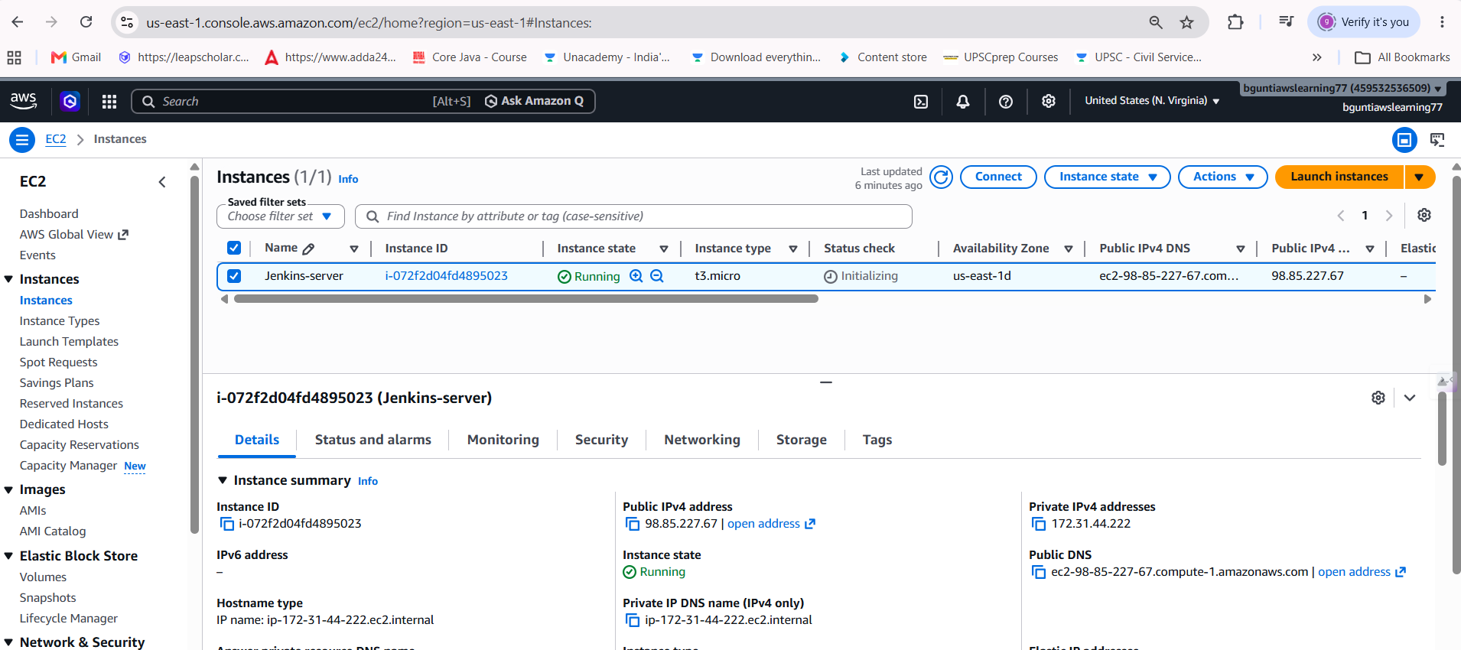

- Give commands to install Jenkins – Browser – Public Ip of Jenkins:8080 – open Jenkins Workspace
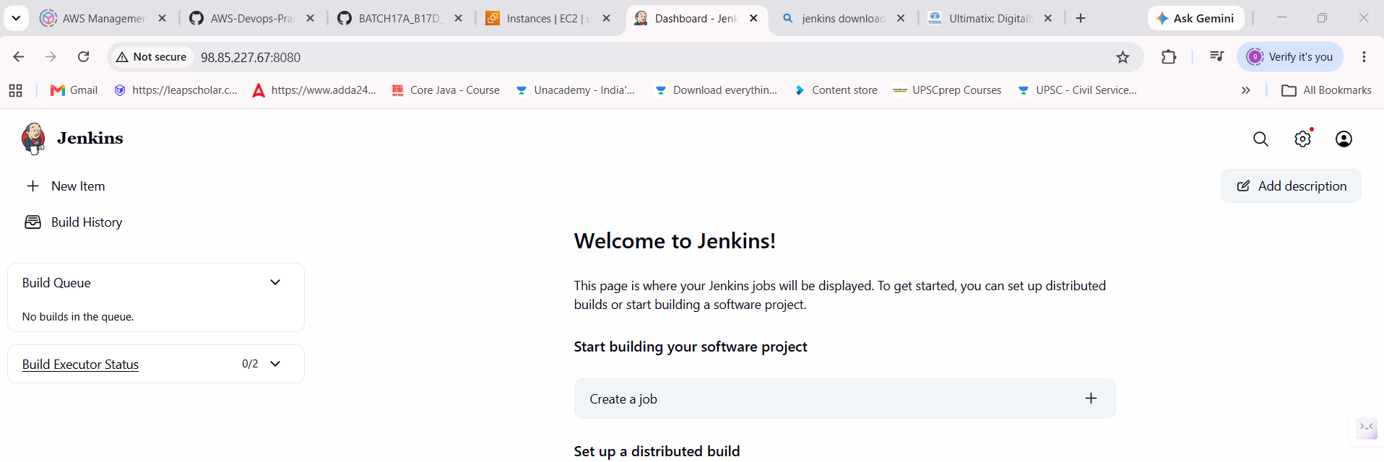

- Also set up Tomcat server (see previous notes)

Jenkins Upgrade:
- Manage Jenkins – system Info – executable-war serving the present Jenkins version.
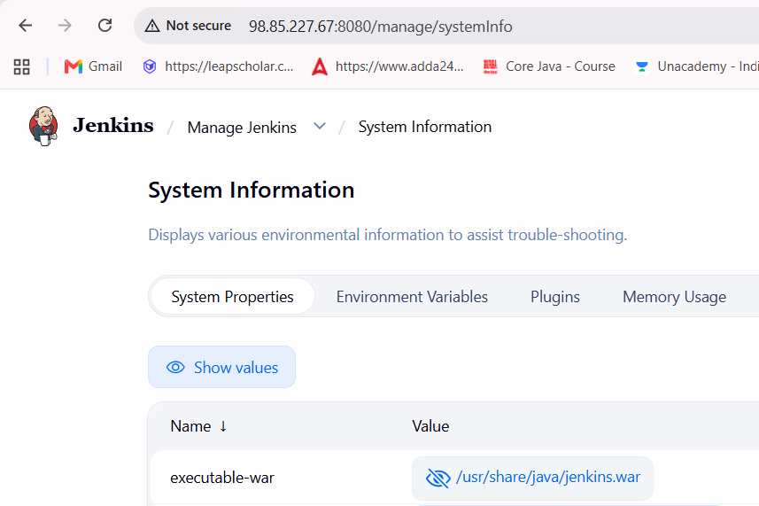
- Go to Jenkins server Ec2 – Terminal
$ cd /usr/share/java
$ ll
You can see old version –> take backup of jenkins.war file
$ cp -rp jenkins.war bkp_jenikins.war_14_apr2026
$ll

- If you want to upgrade the version – you need to download the new/latest version and replace the war file in the executable-war location
- To do the Jenkins upgrade in linux, you need to
- Manage Jenkins – Prepare for Shutdown
$ systemctl stop jenkins
$ systemctl status jenkins

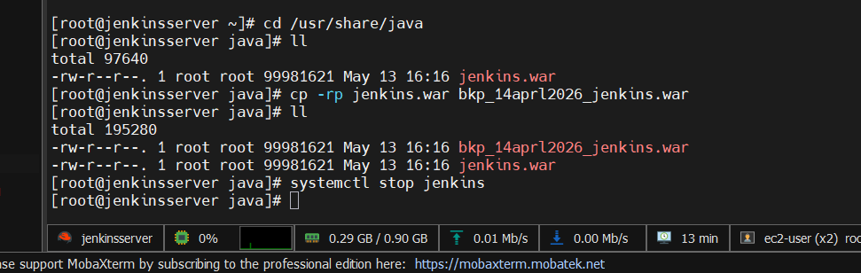

- download latest Jenkins version
$ wget https://get.jenkins.io/war/2.566/jenkins.war
$ll
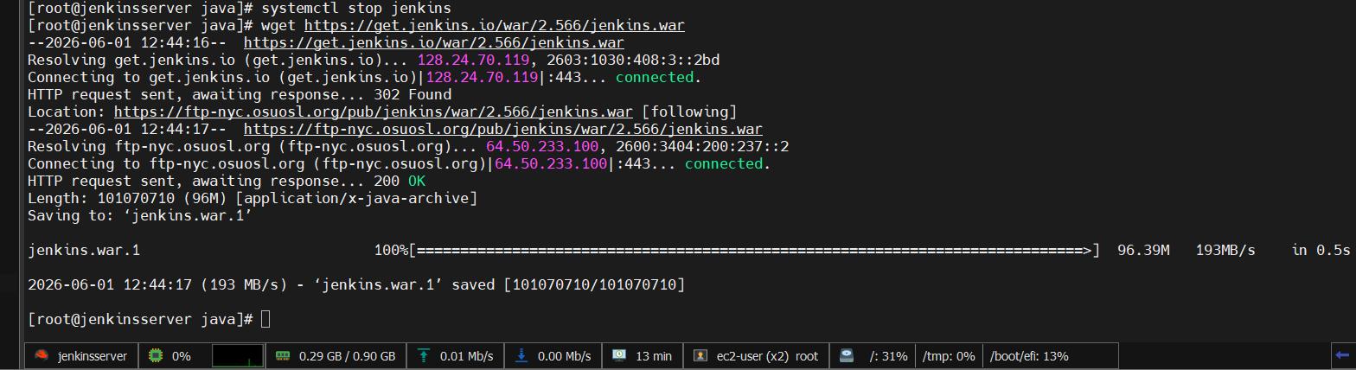
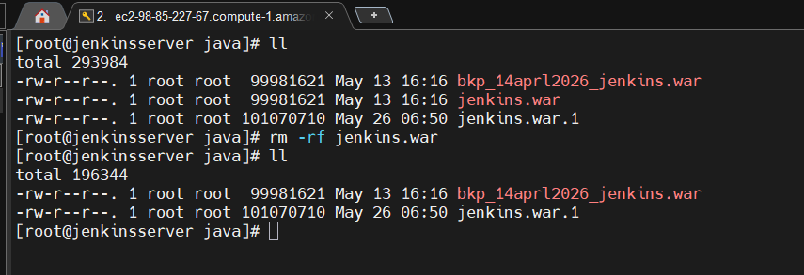
You can see new jenkins
$systemctl start jenkins

- Go and Login to Jenkins
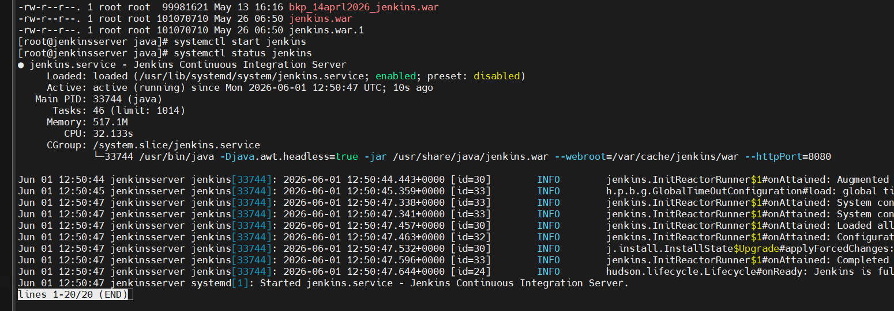
- To Rollback to older version
$ systemctl stop jenkins
$ll
$rm -rf jenkins.war remove new version
$ ll
$ mv bkp_jenikins.war_14_apr2026 jenkins.war
$ systemctl start jenkins
- In Jenkins UI now, you can see old version

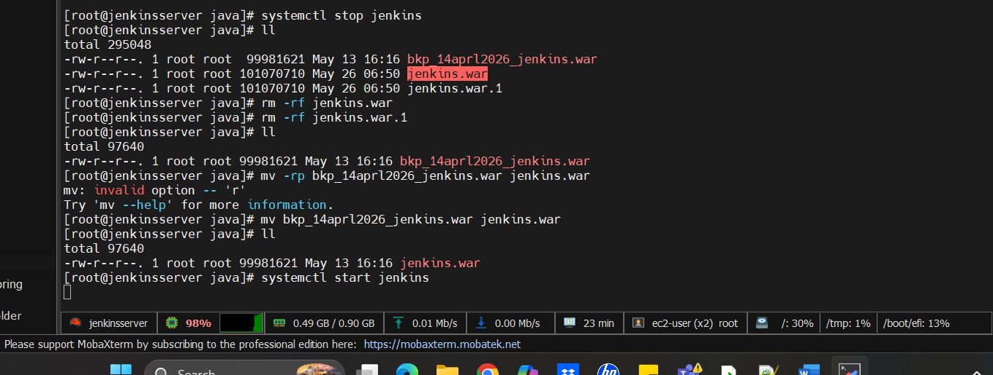

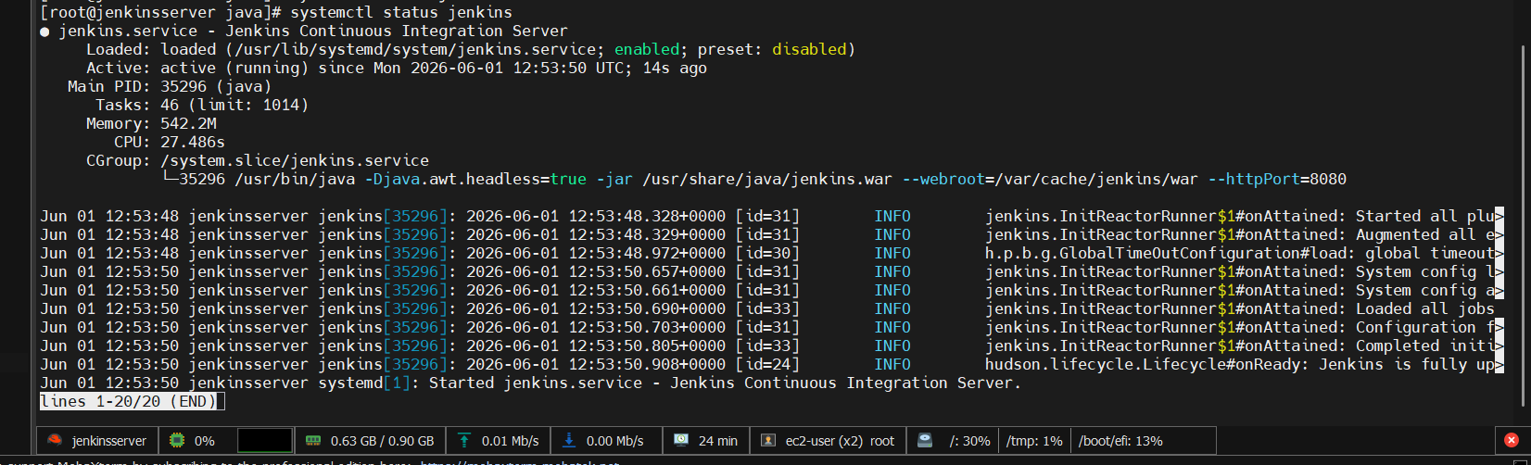

Master – Slave Architecture
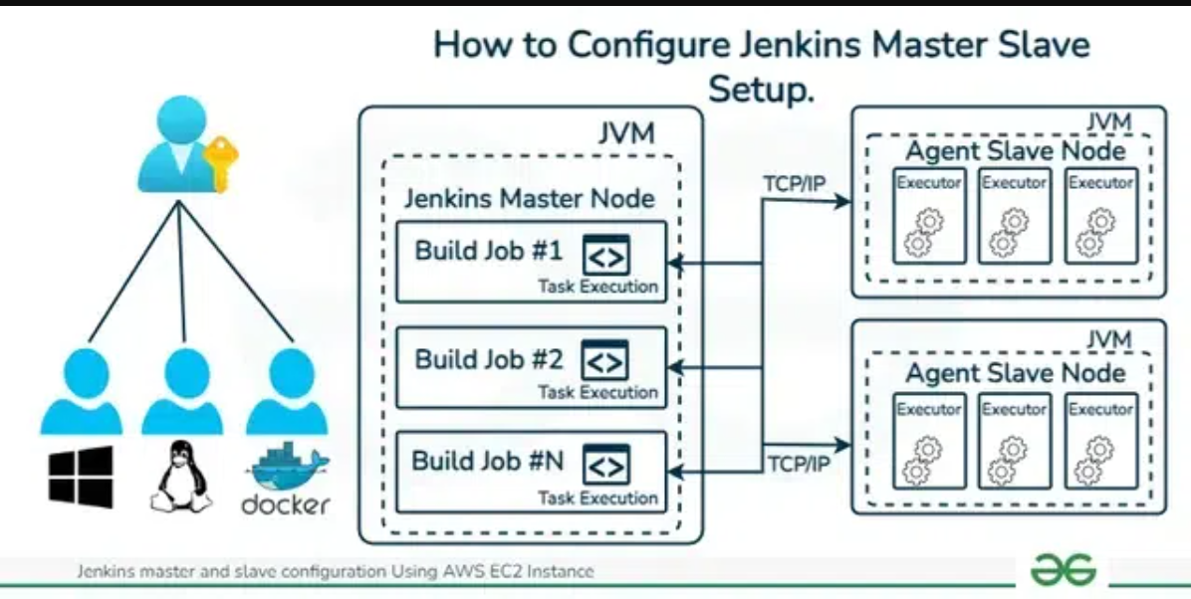

- Create new Ec2 instance – slavenode1 – connect – Mobaxterm Terminal – give hostname as slavenode1
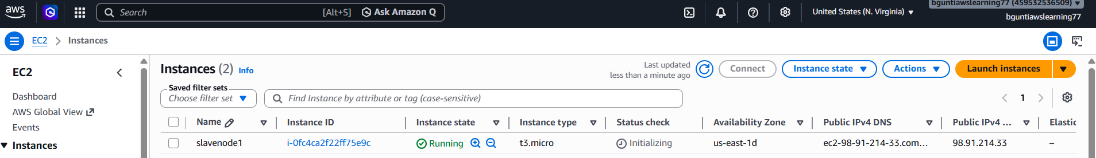

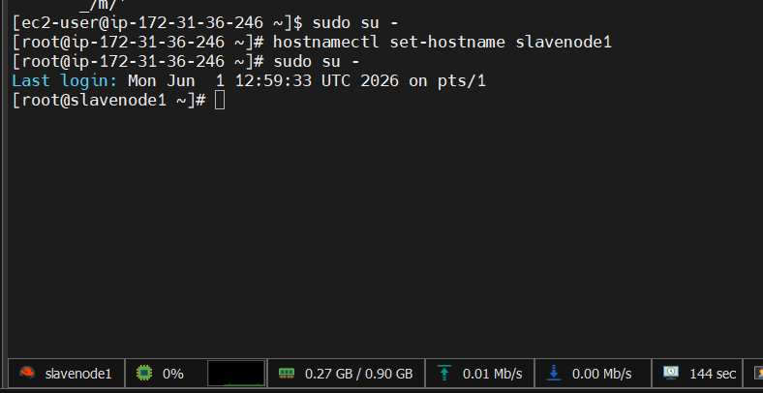

- Now, in Jekins UI -Manage Jenkins – Nodes
- Nodes -> New Node Node name = slavenode1 with Type= permanent agent –> click create –> description = slavenode1
No.of Executers=5 Remote root dir = /tmp (Now on this slave node we need to deploy remote.jar agent.) labels = slavenode1
usage = use as much as possible
launch method == Launch agents via SSH (via pem file) Host = give public ip of slavenode ec2 instance
Credentials == Add , SSH username with private key – give details then Select that cred’s
known hosts file verification strategy == Manually trusted key verification Strategy
Availability == Keep this agent avail as much as possible
save
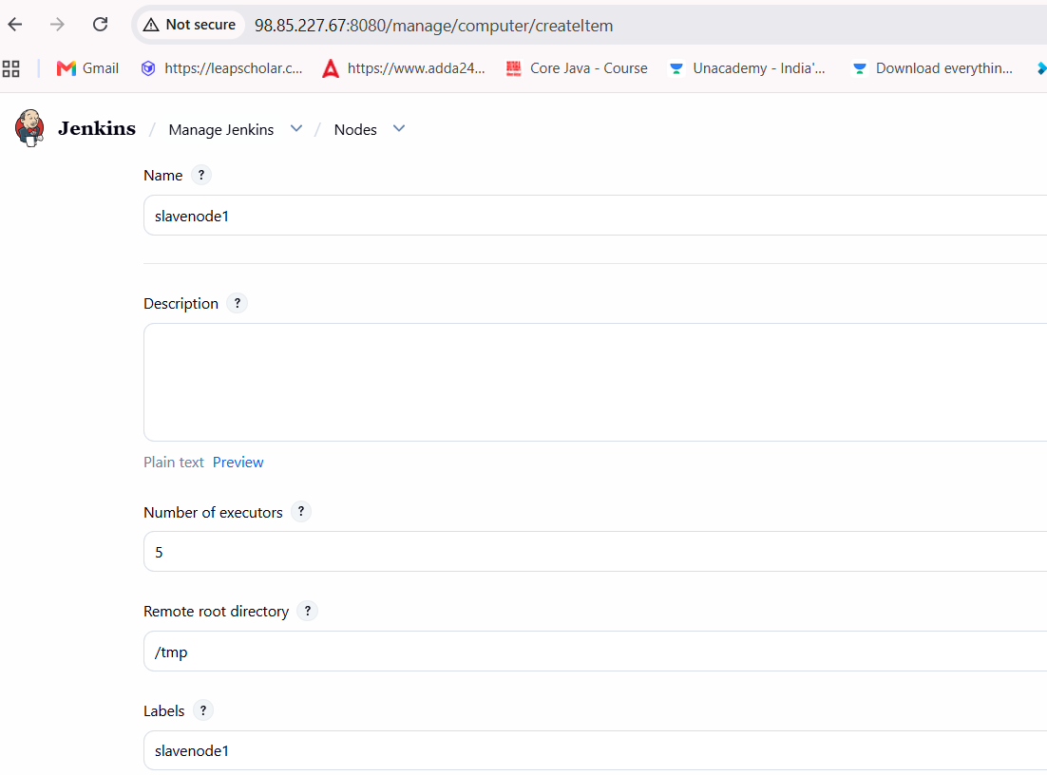
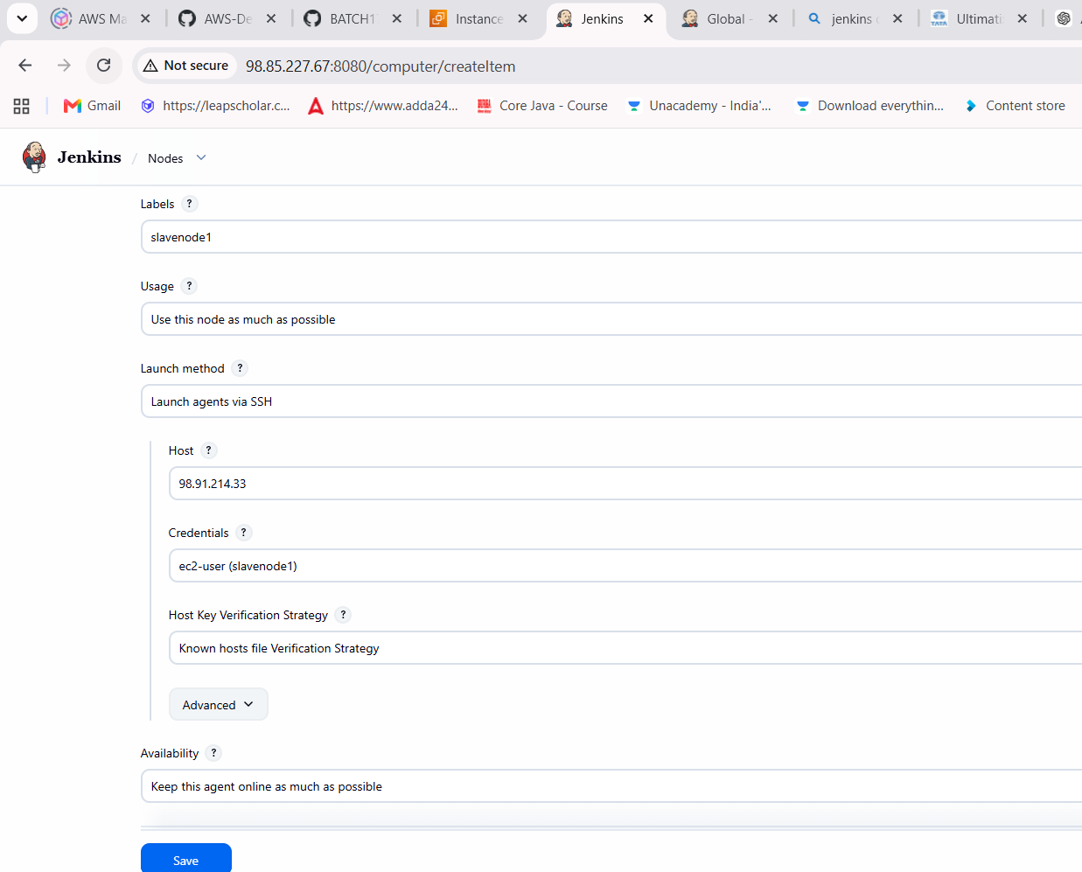

- Select the slavenode1 – Launch agent – you will get error : java command not found
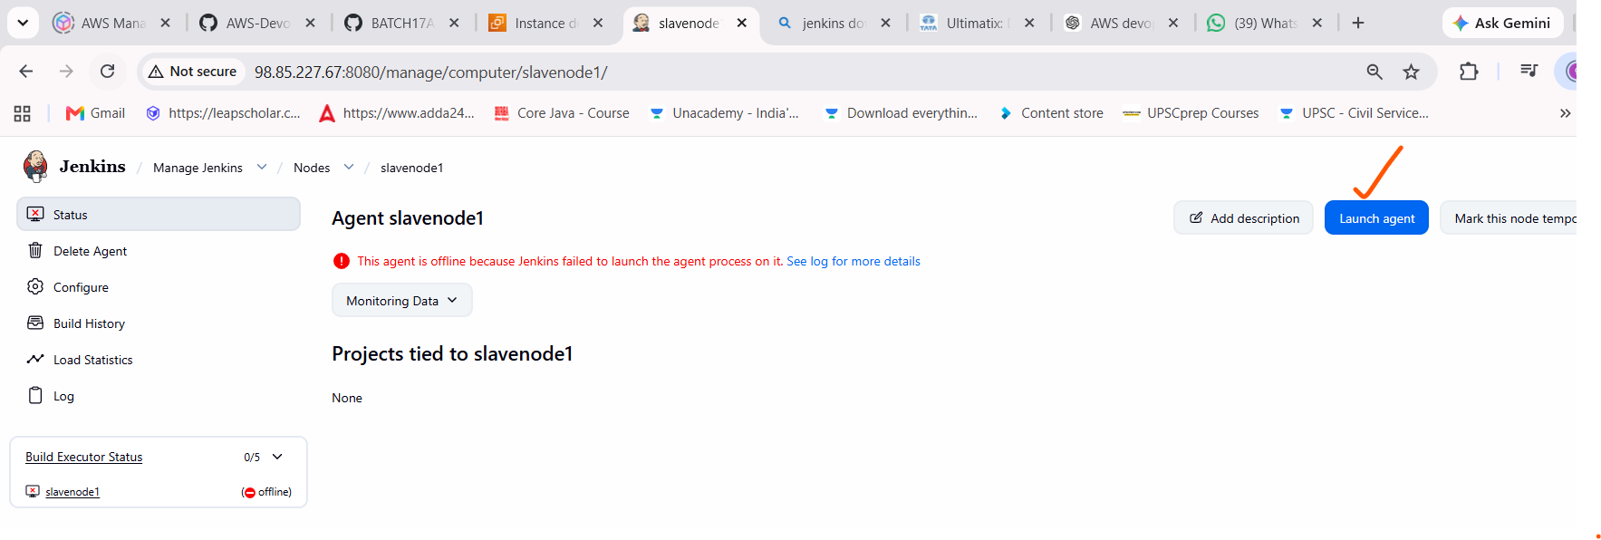
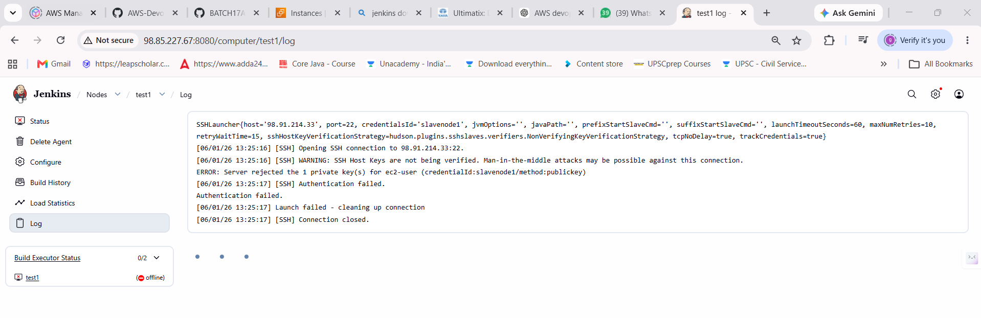
- Go to slavenode1 – Terminal
$ sudo su –
$ yum install java -y
$ yum install git maven -y
- Now, Select the slavenode1 – Launch agent Agent successful connected and online
$ mount
- Jenkins – new item – slavejob – Freestyle –
General – Restruct where this project can run – Label Expression – slavenode1
SCM – Mindcircuit 17d
Build steps – Execute shell – mvn clean install
Save
Build now

Now, you can see artifact in slavenode1 workspace
Put that artifact on tomcat

Jenkins restarts
- Using cli
$systemctl start/stop/status jenkins - After building jobs, Jenkins will be restarted

- Using Jenkins UI

https://....:8080/restart -- hard restart -- issue: Running jobs gets stops abruptly – causes envt issues
https://.....8080/safeRestart -- After building jobs, Jenkins will be restarted

